***Experiment 1***

**Aim:** Unit Testing with pytest: Write and execute unit tests for Python functions using the pytest framework, covering different test cases and assertions.

***Installing Pytest:***

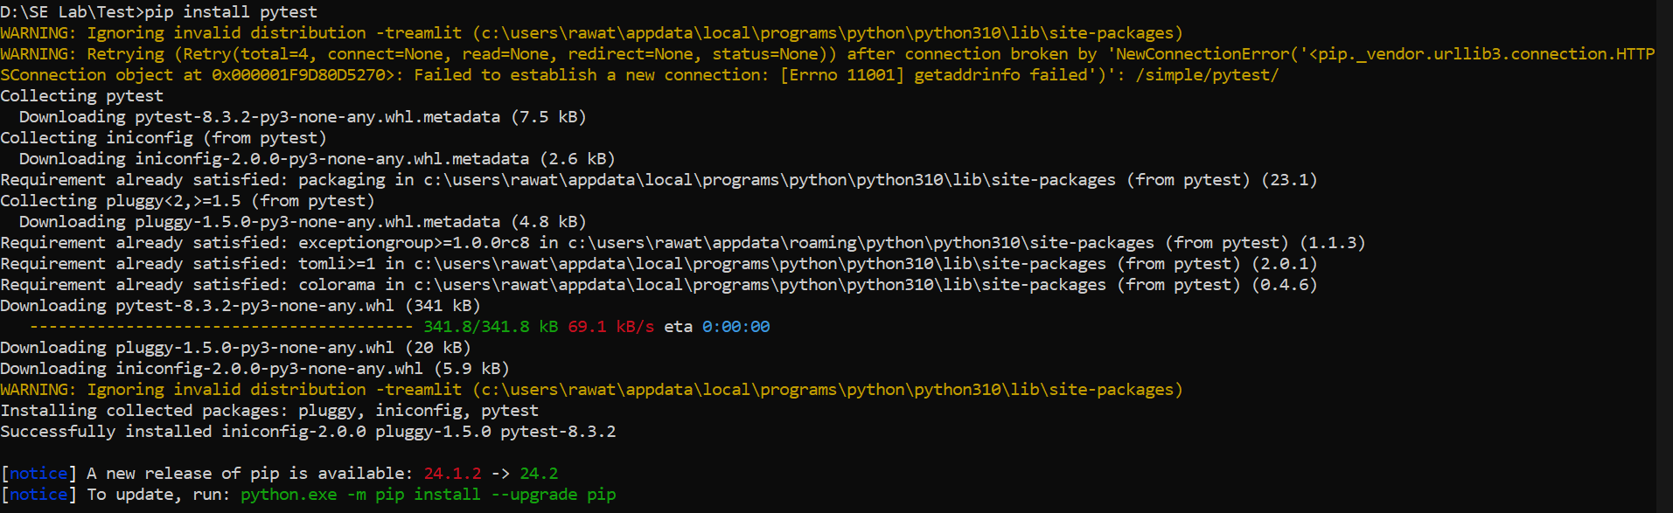

***Fig 1: Installing Pytest in Command Prompt***

***Running Pytest:*** 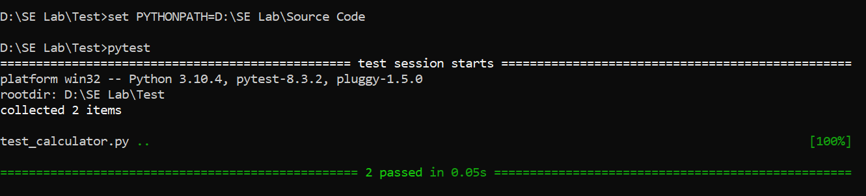

***Fig 2: Running Pytest Command Prompt***